Cpu Sheduling algorithm ?

1 = FCFS Scheduling? = First in, first out (FIFO), also known as first come, first served (FCFS),

FIFO follows the queue of the processess in which they arrived in the cpu

The process that comes first will be executed first and the next process starts only after the previous gets fully executed.

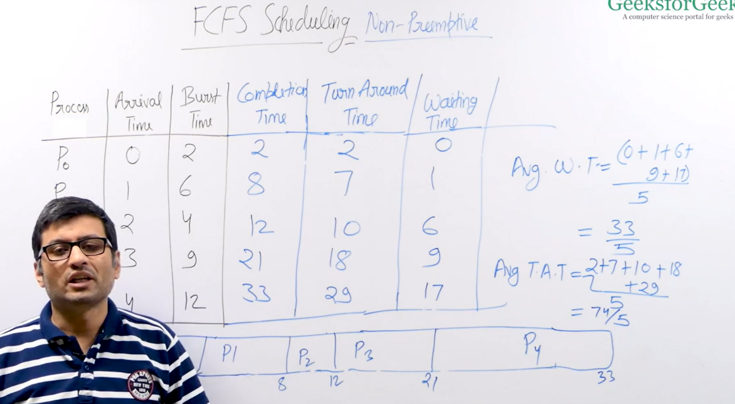

2 = Shortest Job First = **Shortest job first (SJF)** or **shortest job next**, is a scheduling policy that selects the waiting process with the smallest execution time to execute next. SJN is a non-preemptive algorithm. Shortest Job first has the advantage of having a minimum average waiting time among all scheduling algorithms.

**How to compute below times in SJF using a program?**

**1 - Completion Time = Time at which the process I complete**

**2 - Turn Around Time = Completion Time – Arrival Time**

**3 – Waiting Time = Turn Around Time – Burst Time**

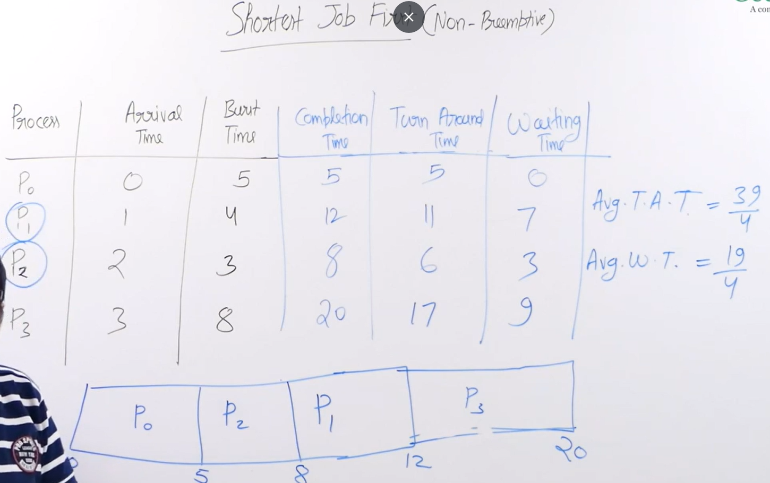

3 =  Shortest Remaining Time First (SRTF) Scheduling? = Shortest remaining time first (SRTF) scheduling is a preemptive scheduling algorithm that selects the process with the least remaining time to complete and executes it. It's also known as shortest job first (SJF) with pre-emption.

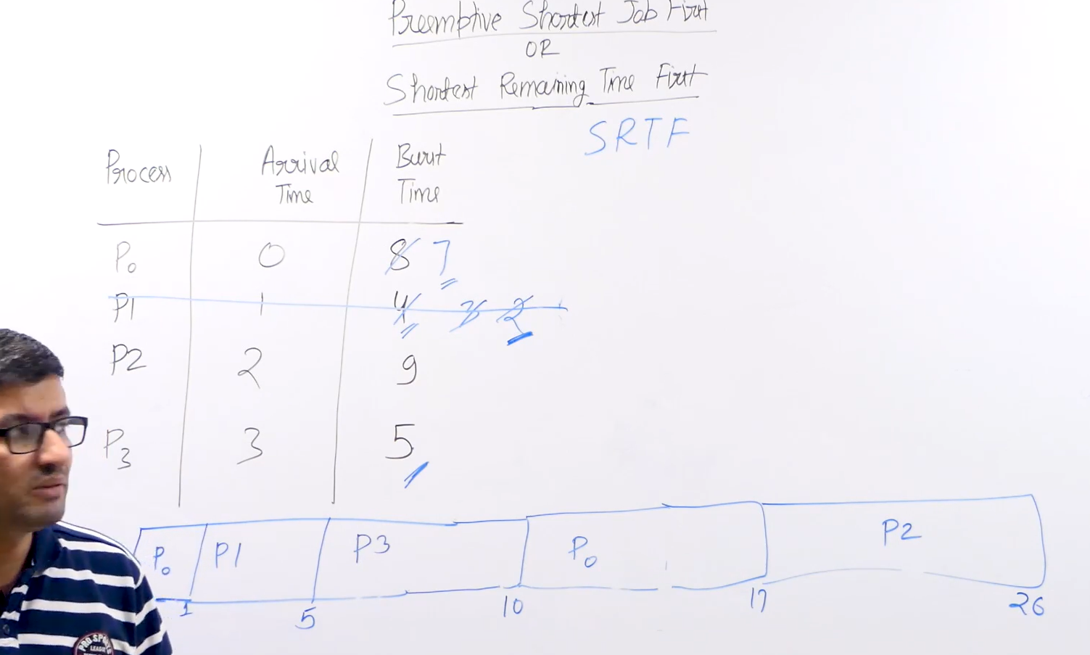

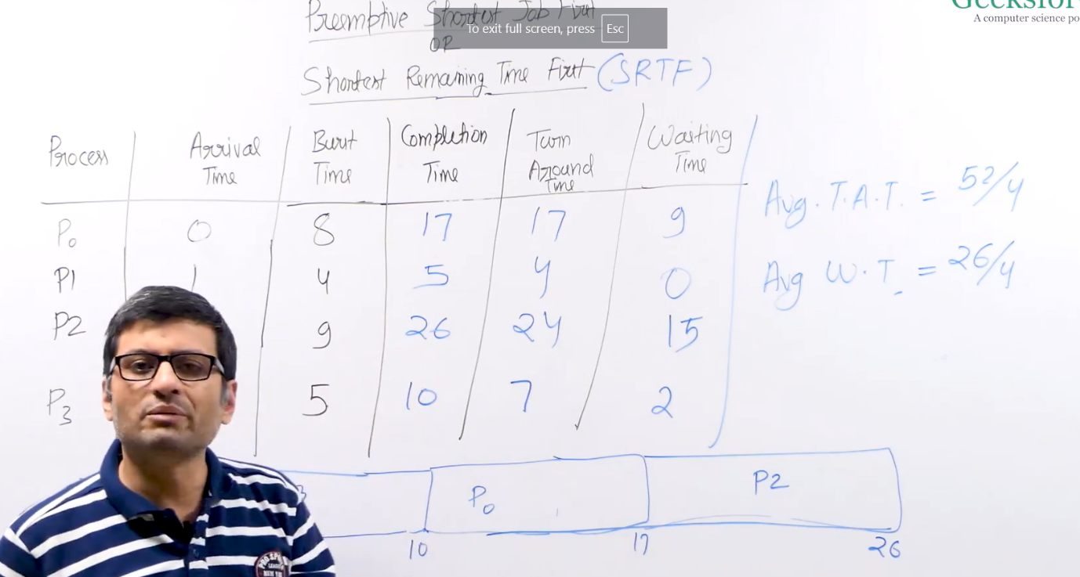

Priority CPU Scheduling? Priority scheduling is one of the most common scheduling algorithms in batch systems. Each process is assigned a priority. The process with the highest priority is to be executed first and so on. Processes with the same priority are executed on a first-come-first-served basis. Are of two Type :->

Non -Primtive = 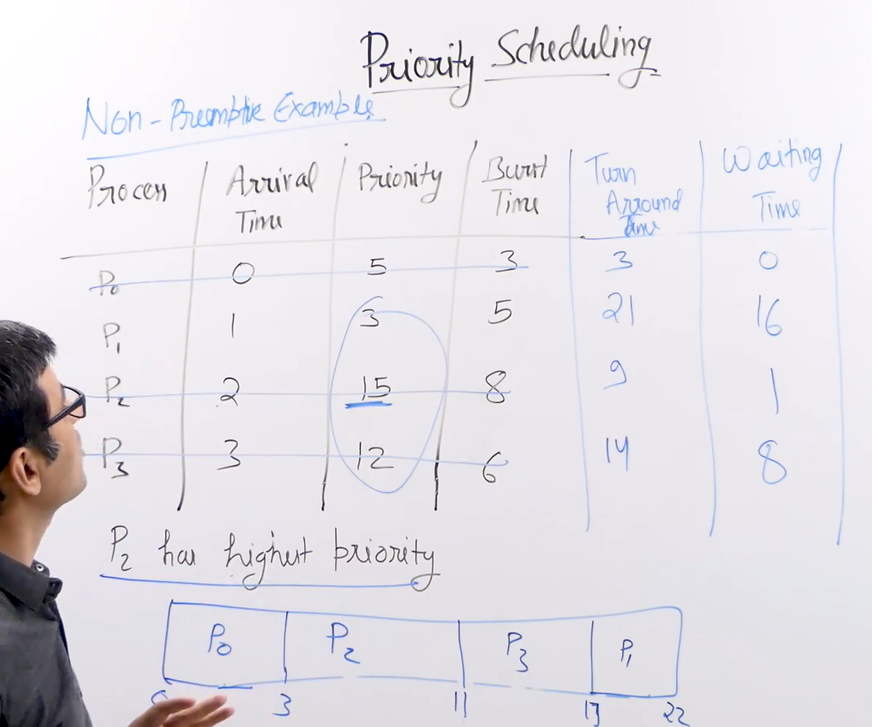

Primtive =

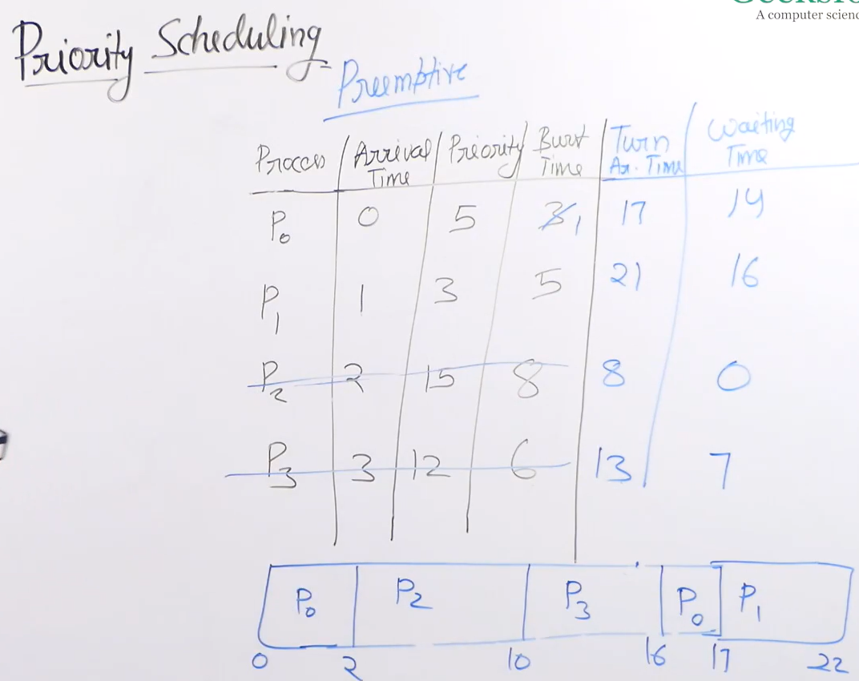

Round Robin scheduling? = **Round Robin** is a [CPU scheduling algorithm](http://quiz.geeksforgeeks.org/gate-notes-operating-system-process-scheduling/) where each process is assigned a fixed time slot in a cyclic way , It is a primtive sheduling algorithm . It is simple, easy to implement, and starvation-free as all processes get fair share of CPU.

